ASSIGNMENT-10.3
NAME:C.ANUKYA REDDY
ROLL NO:2303A52452
BATCH NO:42
TASK 1: AI-Assisted Bug Detection
Prompt:
"I have a Python factorial function that returns 24 for factorial(5) instead of 120. Identify the bug, explain why it occurs, provide a corrected version, and list any edge cases the corrected code should handle."
Error Code:
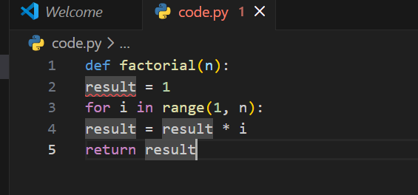
Output:
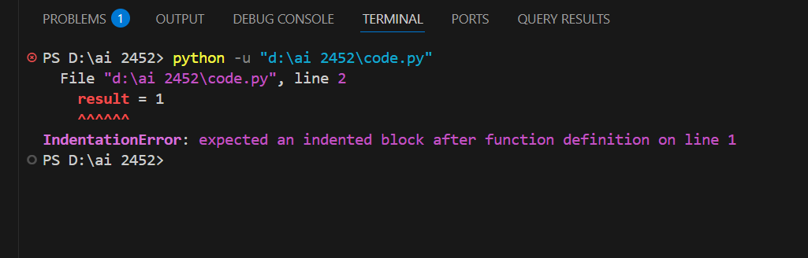
Bug: Off-by-one error
Reason:
range(1, n) stops at n-1, so the loop never multiplies by n.
For factorial(5), it multiplies:
1 × 1 × 2 × 3 × 4 = 24
It misses multiplying by 5.
Corrected Code:
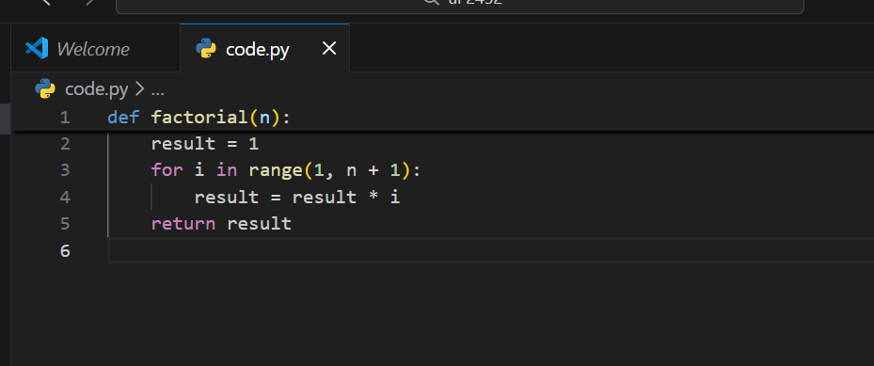
Output:
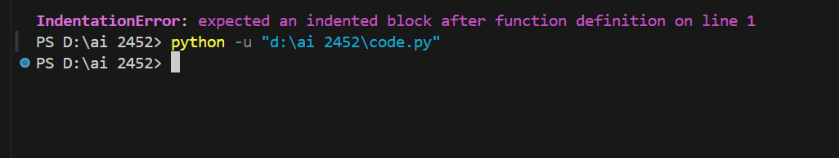
Justification: The prompt clearly states the problem (wrong output), asks for bug identification and explanation, requests a fix, and explicitly requires edge case analysis—ensuring comprehensive AI assistance without ambiguity.
TASK 2: Improving Readability & Documentation
Prompt: Improve this poorly written calculator function by critiquing readability and naming, then rewrite it with descriptive names, complete docstring with examples, exception handling for division by zero, and input validation.
Error Code:
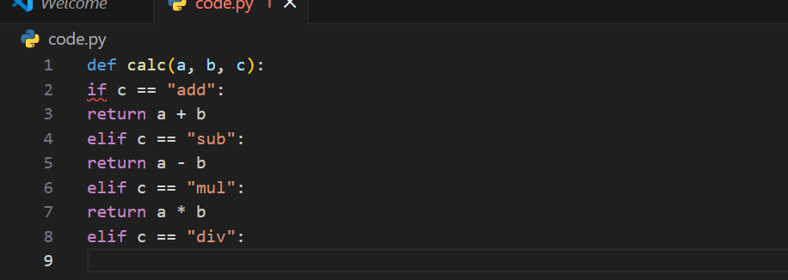
Output:
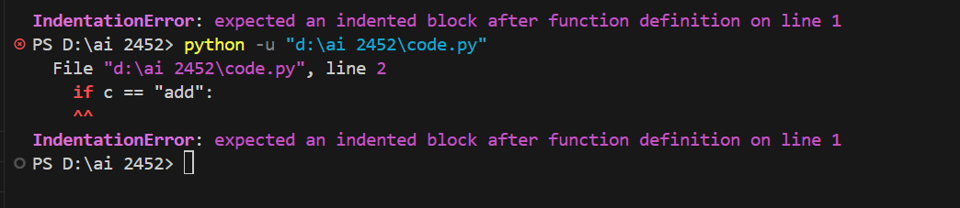
Ai Improved Version:
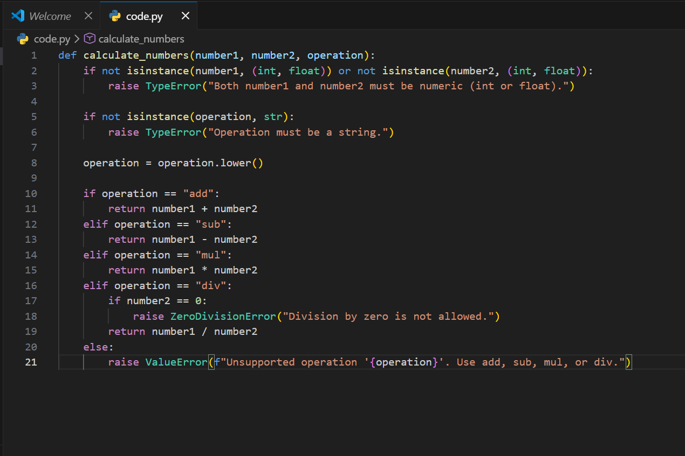
Testing Both Versions With Valid Inputs:
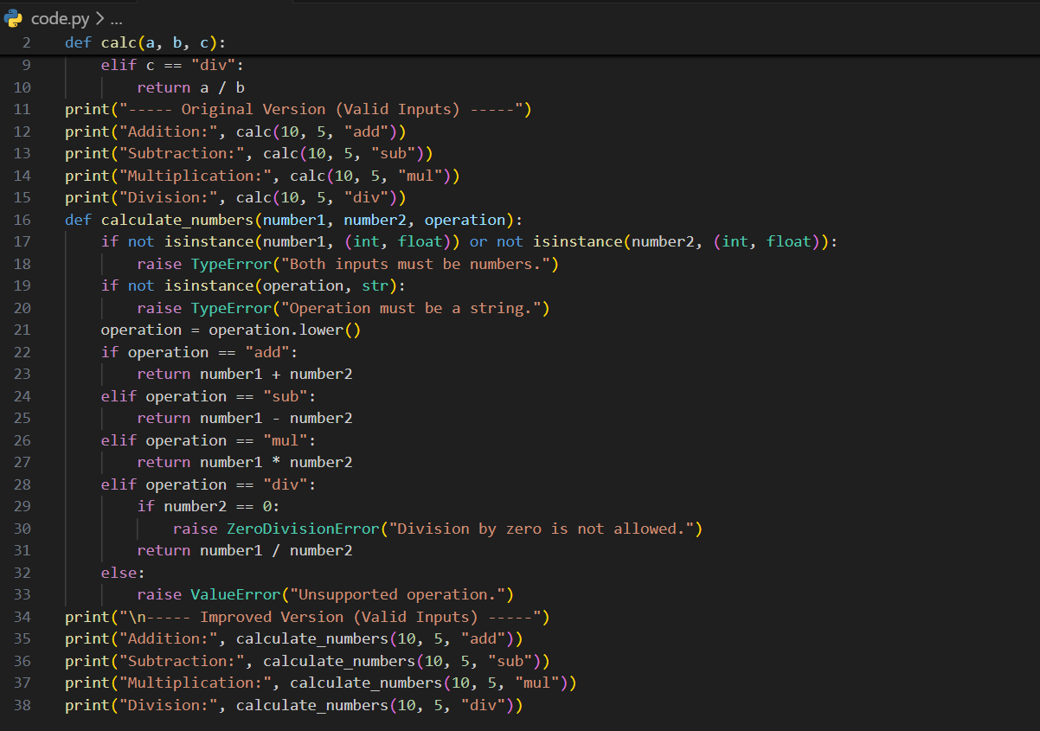
Output:
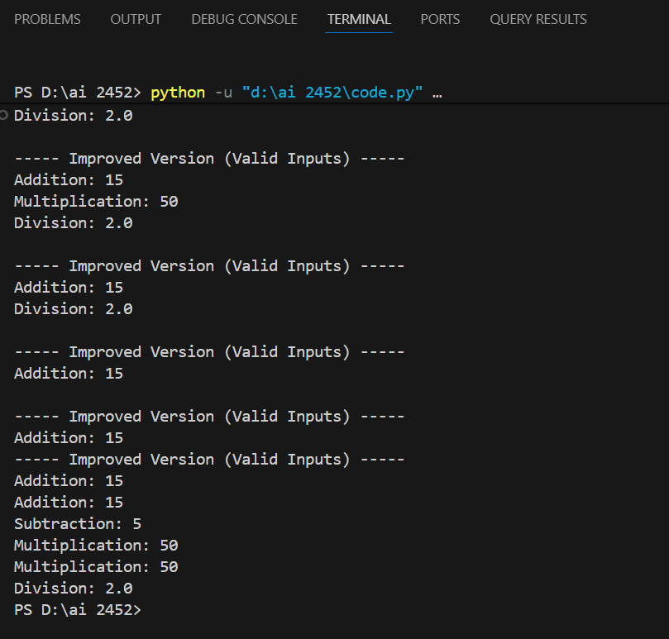
Invalid Inputs:
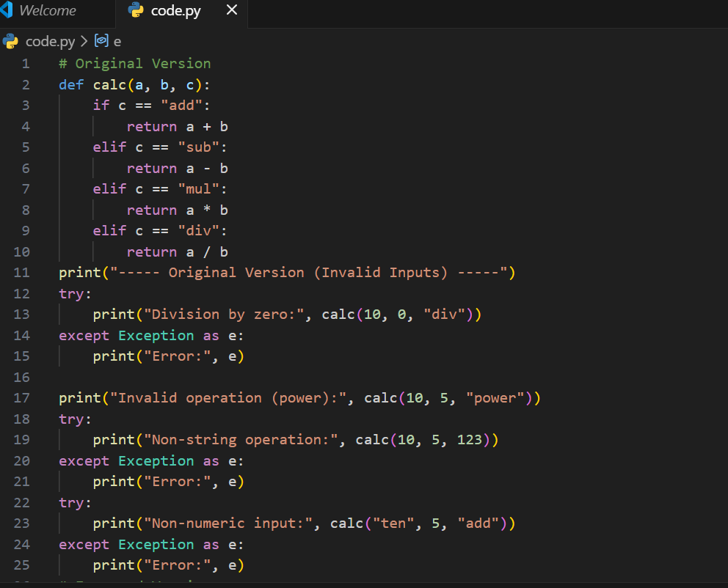
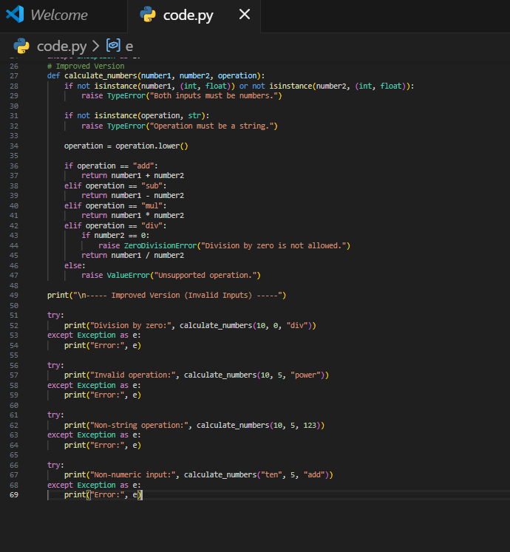
Output:
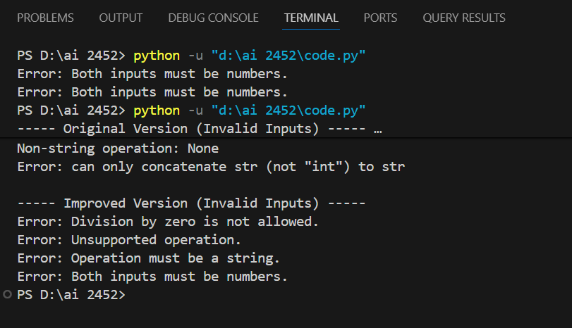
Justification:
The improved version transforms a fragile, undocumented function into a production-ready solution by adding defensive input validation, explicit error handling for edge cases, and comprehensive documentation that enables safe reuse and maintenance.
Task 3: Enforcing Coding Standards
Prompt: Refactor the `Checkprime` function to PEP8 compliance by renaming it to `check_prime`, adding a docstring with type hints, optimizing the algorithm to O(√n), and implementing input validation for edge cases.
Code:
Refactored PEP8-Compliant Code
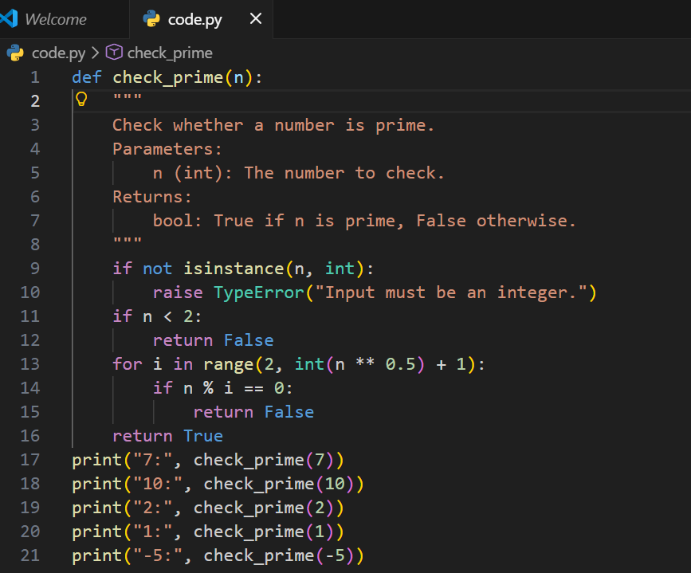
Output:
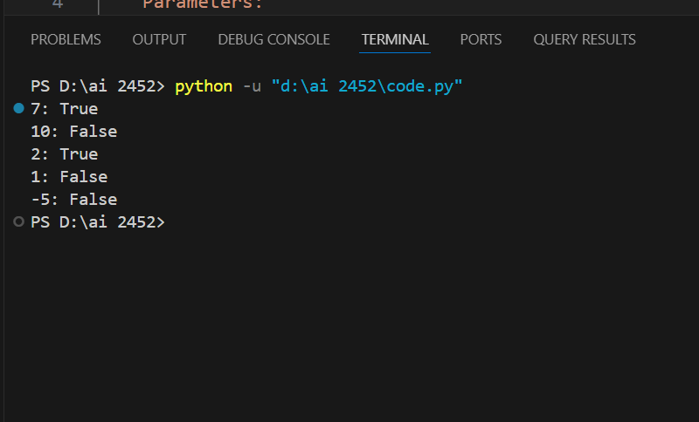
Justification: Automated AI code reviews eliminate manual style enforcement bottlenecks, provide instant feedback on PEP8 violations and security issues, free human reviewers to focus on architectural decisions, and accelerate development cycles while maintaining consistent code quality across large teams.
Task 4: AI as a Code Reviewer in Real Projects
Prompt:
Review the following Python function for readability, naming conventions, input validation, edge cases, type hints, and suggest improvements including generalization of hardcoded values.
Code:
Refactored Function (Based on AI Feedback)
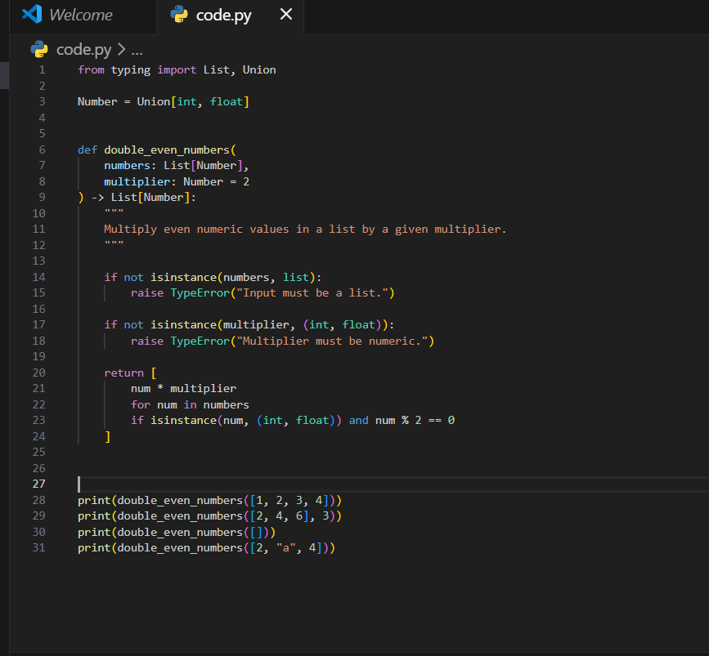
Output:
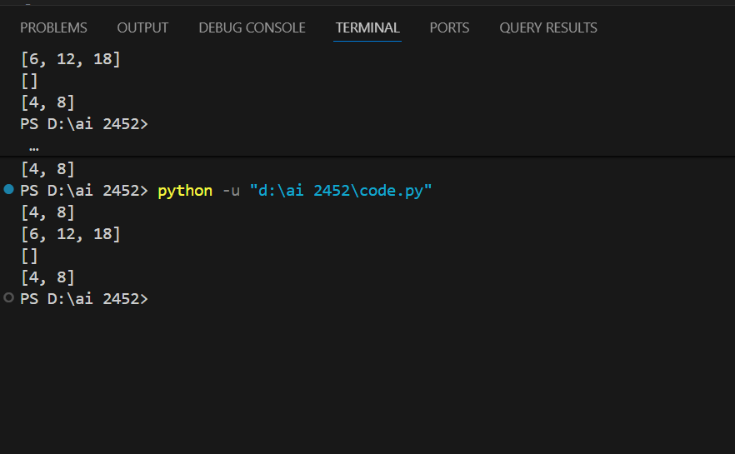
Reflection: AI as Reviewer — Standalone or Assistant?
AI should act as an assistant rather than a standalone reviewer. While AI excels at detecting style issues, edge cases, and enforcing best practices consistently, it lacks full contextual understanding of business logic and project-specific constraints. Human reviewers bring domain knowledge, architectural insight, and ethical judgment. Together, AI and humans form a more efficient and reliable code review process, especially in large-scale collaborative projects.
Justification:
This prompt ensures the AI evaluates code quality, robustness, maintainability, and scalability while preserving functionality.
Task 5: AI-Assisted Performance Optimization
Prompt: Analyze the time complexity of this Python function, suggest performance optimizations using built-in functions or NumPy if appropriate, and provide an optimized version with execution time comparison
Code: Testing with a Large Dataset
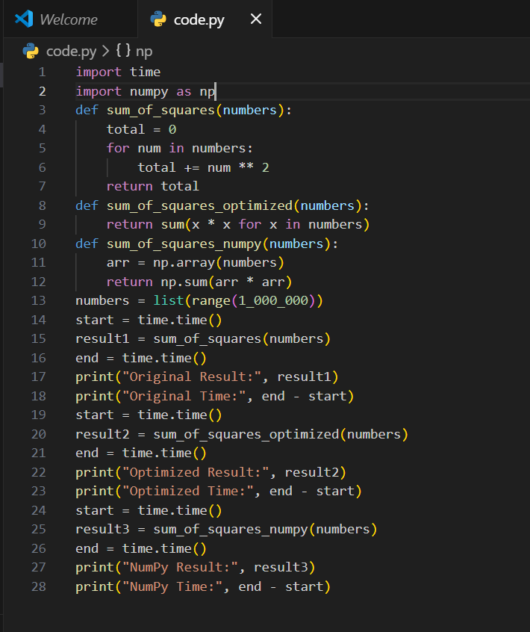
Output:
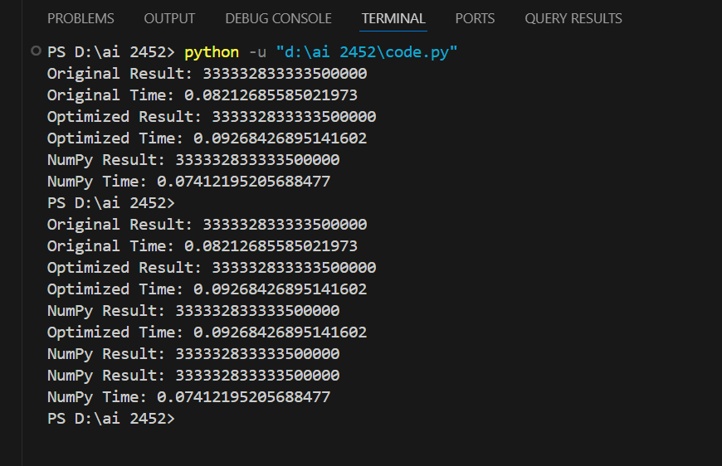
Justification:
This prompt ensures the AI evaluates algorithm efficiency and proposes practical optimizations while maintaining correctness and scalability.

